## **Crime Rate Prediction**

***Project submitted in partial fulfillment of the requirements for the award of the degree of***

# BACHELOR OF TECHNOLOGY

### IN

**COMPUTER SCIENCE AND ENGINEERING**

**PANNIRU SOUMYA (18C91A0569)**

**NEERADI ARYAN RAJ (18C91A0561)**

**PINGILI RAKESH REDDY (18C91A0575)**

**Under the Esteemed guidance of**

**DR.B.NARSIMHA**

Professor & Head,

Dept. of CSE



DEPARTMENT OF COMPUTER SCIENCE AND ENGINEERING

**HOLY MARY INSTITUTE OF TECHNOLOGY & SCIENCE**

**(COLLEGE OF ENGINEERING)**

***(Approved by AICTE New Delhi, Permanently Affiliated to JNTU Hyderabad, Accredited by NAAC with ‘A’ Grade)***

**Bogaram (V), Keesara (M), Medchal District -501 301.**

### 2021 - 2022

**HOLY MARY INSTITUTE OF TECHNOLOGY & SCIENCE**

#### (COLLEGE OF ENGINEERING)

***(Approved by AICTE New Delhi, Permanently Affiliated to JNTU Hyderabad, Accredited by NAAC with ‘A’ Grade)***

**Bogaram (V), Keesara (M), Medchal Dist-501301.**

### DEPARTMENT OF COMPUTER SCIENCE AND ENGINEERING



**CERTIFICATE**

This is to certify that the mini project entitled “**Crime Rate Prediction**” is being submitted by PANNIRU SOUMYA (18C91A0569), NEERADI ARYAN RAJ (18C91A0561), PINGILI RAKESH REDDY (18C91A0575), in Partial fulfillment of the academic requirements for the award of the degree of Bachelor of

Technology in “COMPUTER SCIENCE AND ENGINEERING” HOLY MARY INSTITUTE OF

TECHNOLOGY & SCIENCE, JNTU Hyderabad during the year 2021- 2022.

**INTERNAL GUIDE HEAD OF THE DEPARTMENT**

DR .B.NARSIMHA M.Tech, Ph.D. DR .B.NARSIMHA M.Tech, Ph.D.

Professor & HOD Professor & HOD

Dept. of Computer Science & Engineering. Dept. of Computer Science & Engineering

### EXTERNAL EXAMINER

**ACKNOWLEDGEMENT**

The satisfaction and euphoria that accompany the successful completion of any task would be incomplete without the mention of the people who made it possible, who’s constant guidance and encouragement crowns all effort with success.

I take this opportunity to express my profound gratitude and deep regards to My Guide **DR.B.NARSIMHA. (Head of the department),** Dept. of Computer Science & Engineering, Holy Mary Institute of Technology & Science for his / her exemplary guidance, monitoring and constant encouragement throughout the project work.

My special thanks to **Dr. B. Narsimha, Head of the Department**, Dept. of Computer Science & Engineering, Holy Mary Institute of Technology & Science who has given an immense support throughout the course of the project.

I also thank to **Dr. P. Bhaskara Reddy,** the **honorable Director** of my college Holy Mary Institute of Technology & Science for providing me the opportunity to carry out this work.

At the outset, I express my deep sense of gratitude to the beloved **Chairman A. Siddartha Reddy** of **Holy Mary Institute of Technology & Science**, for giving me the opportunity to complete my course of work

I am obliged to **staff members** of Holy Mary Institute of Technology & Science for the valuable information provided by them in their respective fields. I am grateful for their cooperation during the period of my assignment.

Last but not the least I thank **ALMIGHTY** and My **Parents**, and **Friends** for their constant encouragement without which this assignment would not be possible.

**PANNIRU SOUMYA (18C91A0569)**

**NEERADI ARYAN RAJ (18C91A0561)**

**PINGILI RAKESH REDDY (18C91A0575)**

**DECLARATION**

This is to certify that the work reported in the present project titled **“CRIME RATE PREDICTION”** is a record ofwork done by me in the Department of Computer Science & Engineering, Holy Mary Institute of Technology and Science.

No part of the thesis is copied from books/journals/internet and wherever the portion is taken, the same has been duly referred in the text the reported are based on the project work done entirely by me not copied from any other source.

**PANNIRU SOUMYA (18C91A0569)**

**NEERADI ARYAN RAJ (18C91A0561)**

**PINGILI RAKESH REDDY (18C91A0575)**

**INDEX**

ABSTRACT

Content Page No.

### INTRODUCTION

* 1. Problem Statement ……………………………………………………………...6
  2. Objectives ………………………………………………………………………7
  3. Existing System …………………………………………………………………8
  4. Proposed System ………………………………………………………………...9

### LITERATURE SURVEY

* 1. Existing System ………………………………………………………………….12
  2. Proposal System ………………………………………………………………….13
  3. Summary …………………………………………………………………………14.

**3.SOFTWARE REQUIREMENTS SPECIFICATIONS**

* 1. Software Requirements ……………………………………………………….....15
  2. Hardware Requirements …………………………………………………………15

### SYSTEM DESIGN

1. System Architecture ……………………………………………………………16

### IMPLEMENTATION

* 1. Environmental Setup …………………………………………………………….19
  2. Module Description ……………………………………………………………...20
  3. Software Description ……………………………………………………………..21
  4. Sample Code ……………………………………………………………………...22

### SYSTEM TESTING

* 1. Tests ………………………………………………………………………………..23

### RESULTSCREEN SHOT ……………………………………………26

### CONCLUSION ………………………………………………………..27

### BIBLIOGRAPHY……………………………………………………...28

**LIST OF SCREEN SHOTS** **II**

1. SAR-Crime analyzer home page ……………………………………………………35
2. Admin login page …………………………………………………………………...36
3. Admin home page …………………………………………………………………...36
4. Admin-view messages ……………………………………………………………….37
5. Admin desk …………………………………………………………………………. 37
6. Police login page ……………………………………………………………………. 38
7. Police home page …………………………………………………………………….38
8. Police contact admin ………………………………………………………………... 39
9. Case analysis home …………………………………………………………………. 41
10. Major crimes in India ……………………………………………………………….. 42
11. Crime against women ………………………………………………………………..42
12. Crime against child ………………………………………………………………….43
13. Crime reports home …………………………………………………………………44
14. Crime report form …………………………………………………………………...45
15. Crime prediction home ……………………………………………………………...45
16. Crime prediction results ……………………………………………………………..46
17. Statistics of crime reports in India ………………………………………………….47

**ABSTRACT**

# This project involves building a prediction system that can analyze and predict the crime rate of a particular location. The system needs to be fed with relevant data. It uses k-means data mining algorithm to predict the crime rate.

# The k-means algorithm can cluster co-offenders and organized crime groups by detecting relevant crime patterns via hidden links, link prediction and statistical analysis of crime data.

# With the increasing advent of computerized systems, crime data analysts can help the Law enforcement officers to speed up the process of solving crimes.

# Using the concept of data mining we can extract previously unknown, useful information from an unstructured data. Here we have an approach between computer science and criminal justice to develop a data mining procedure that can help solve crimes faster.

# Chapter 1: INTRODUCTION

## **PROBLEM STATEMENT**

In our country India the current system of the Supreme Security Committee (SSC) is a manual system. We aim to explore in this work the applicability of data mining technique in the efforts of crime prevention with particular emphasis to the dataset we collected from web sites (Kaggle), news sites, blogs, social media, RSS feeds etc. We propose to implement a model that could help us to extract crime patterns. These patterns will be applied to some data mining algorithms such as association rules mining and clustering to classify crime records on the basis of the values of attributes crime. Applying such algorithms will illustrate the overall results of using both algorithms to perform better results rather in association rule mining or in clustering. The rules generated by association rule mining could be easily presented in human language which might be used by SSC officers to help them decided a crime prevention strategy. Also, from this data analysis technic we will come to know:

* + - How crime data analysis is a law enforcement function that involves systematic analysis for identifying and analyzing patterns and trends in crime and disorder?
    - How information on patterns can help law enforcement agencies deploy resources in a more effective manner, and assist detectives in identifying and apprehending suspects?
    - How crime analysis also plays a role in devising solutions to crime problems, and formulating crime prevention strategies?

## **OBJECTIVE**

The objective of this project is:

* + - To identify the nature of crime and the crime prevention process to extracting named entities from narrative reports.
    - To explore and choose among the various data mining software that support clustering and association rule mining technique to experiment with crime records.
    - To build and train as well as test the performance of the model.
    - To interpret and analyze the results of the model that how strong is the model to extract crime data patterns.
    - To compare the clustering and association rules data mining techniques and select the one which performs the best results.
    - To compare our proposed model with some recent working model.
    - Predicting crime before it takes place.
    - Predicting hotspots of crime.
    - Understanding crime pattern.
    - Classify crime based on location.
    - Analysis of crime in India.

## **MOTIVATION**

Day by day the crime rate is increasing considerably. Crime cannot be predicted since it is neither systematic nor random. Also, the modern technologies and hi-tech methods help criminals in achieving their misdeeds. According to Crime Records Bureau crimes like burglary, arson, etc have been decreased while crimes like murder, sex abuse, gang rape, etc have been increased. Even though we cannot predict who all may be the victims of crime but can predict the place that has probability for its occurrence. The predicted results cannot be assured of 100% accuracy but the results shows that our application helps in reducing crime rate to a certain extent by providing security in crime- sensitive areas. So, for building such a powerful crime analytics tool we have to collect crime records and evaluate it. Crime analysis and prevention is a systematic approach for identifying and analyzing patterns and trends in crime.

The crime analysis can be performed procedure which is similar to figure (Figure1) which specifies each module which is used for data mining and machine learning algorithm to predict the crime or form group of clusters of criminals according to crime records. The criminals can hold certain properties and their crime characteristics and crime careers may vary from one criminal to another. Such a type of information can be taken as the input dataset. The input dataset is given to a pre-processor which performs the pre-processing based on the requirements. Our system can predict regions which have high probability for crime occurrence and can visualize crime prone areas. With the increasing advent of computerized systems, crime data analysts can help the Law enforcement officers to speed up the process of solving crimes. It will also help to create a somewhat safer, crime-free neighborhood for the citizens as they will be more aware of different types of crimes occurring and the time in which it is more likely to happen.

## **EXISTING** **SYSTEM**

* Crimes are documented and stored physically and they are not quick to access and read the relevant data.
* It is not possible to accurately predict the crime patterns and detect crime groups with the file system.

## **PROPOSED** **SYSTEM**

* By our project we can modify the existing system in such a way that anybody can easily understand and use our system, and its user friendly system.
* Our system can predict regions which have high probability for crime occurrence and can visualize crime prone areas.
* Using the concept machine learning we can extract previously unknown, useful information from an unstructured data.

# Chapter 2: LITERATURE SURVEY

Historically solving crimes has been the right of the criminal justice and law enforcement specialists. With the increase in the use of the computerized systems to track crimes and trace criminals, computer data analysts have started lending their hands in helping the law enforcement officers and detectives to speed up the process of solving crimes. Criminology is process that is used to identify crime and criminal characteristics. The criminals and the crime occurrence possibility can be assessed with the help of criminology techniques.

The criminology aids the police department, the detective agencies and crime branches in identifying the true characteristics of a criminal. The criminology department has been used in the proceedings of crime tracking ever since 1800. Crimes are a social nuisance and cost our society dearly in several ways. Even, the Indian Government has taken steps to develop applications and software for the use of State and Central Police in relation with the National Crime Records Bureau (NCRB). Any research that can help in solving crimes faster will pay for itself. About 10% of the criminals commit about 50% of the crimes. People who study criminology will be able to identify the criminals based on the traces, characteristics and methods of crime which can be collected from the crime scene. In the middle of 1990s, data mining came into existence as a strong tool to extract useful information from large datasets and find the relationship between the attributes of the data.

Data mining originally came from statistics and machine learning as an interdisciplinary field, but then it was grown a lot that in 2001 it was considered as one of the top 10 leading technologies which will change the world. According to many researchers such as Nath, solving crimes is a difficult and time-consuming task that requires human intelligence and experience and data mining is one technique that can help us with crime detection problems. For solving crimes faster, we have to develop a data mining paradigm that performs an interdisciplinary approach between computer science and criminal justice. As said earlier, the Criminology is a process that aims to identify crime characteristics and it is one of the most important fields for applying data mining. By using this, data mining algorithms will be able to produce crime reports and help in the identification of criminals much faster than any human could. Because of this remarkable feature, there is a growing demand for data mining in criminology. Actually, Crime analysis is a process which includes exploring the behavior of the crimes, detecting crimes and their relationships with criminals. The huge volume of crime and criminal datasets and the complexity of relationships between these kinds of information have made criminology an appropriate field for applying data mining techniques. Identifying crime characteristics is the first step for proceeding with any further analysis.

The quality of data analysis depends greatly on background knowledge of analyst. A criminal can range from civil infractions such as illegal driving to terrorism mass murder such as the 9/11 attacks, therefore it is difficult to model the perfect algorithm to cover all of them. The knowledge that is gained from Data Mining approaches is a very useful and this can help and support, the police. More specifically, we can use classification and clustering based models to help in identification of crime patterns and criminals. The wide range of data mining applications in the criminology has made it an important field of research. Data mining systems have played as a key role in assisting humans in this forensic domain and criminology domain. This makes it one of the most challenging decision- making environments for research.

Data mining is one of the most useful techniques that help entrepreneurs, researchers, and individuals to extract valuable information from huge sets of data. Data mining is also called Knowledge Discovery in Database (KDD). The knowledge discovery process includes Data cleaning, Data integration, Data selection, Data transformation, Data mining, Pattern evaluation, and Knowledge presentation. The process of extracting information to identify patterns, trends, and useful data that would allow the business to take the data- driven decision from huge sets of data is called Data Mining. In other words, we can say that Data Mining is the process of investigating hidden patterns of information to various perspectives for categorization into useful data, which is collected and assembled in particular areas such as data warehouses, efficient analysis, data mining algorithm, helping decision making and other data requirement to eventually cost-cutting and generating revenue. Types of data mining are Relational Database, Data Warehouse, Data Repositories, Object-Relational Database, Transactional Database etc. Data science is an inter-disciplinary field that uses scientific methods, processes, algorithms and systems to extract knowledge and insights from many structural and unstructured data. Data science is related to data mining, machine learning and big data.

## **EXISTING** **SYSTEM**

* Crimes are documented and stored physically and they are not quick to access and read the relevant data.
* It is not possible to accurately predict the crime patterns and detect crime groups with the file system.

## PROPOSED SYSTEM

* By our project we can modify the existing system in such a way that anybody can easily understand and use our system, and its user friendly system.
* Our system can predict regions which have high probability for crime occurrence and can visualize crime prone areas.
* Using the concept machine learning we can extract previously unknown, useful information from an unstructured data.

# 2.3 APPLICATIONS

# Crime Analysis & Prediction System is a system to analyze & detect crime hotspots & predict crime. It collects data from various data sources - crime data from Open Data sites, US census data, social media, traffic & weather data etc.

# Detect, Analyze & predict crime.

# Help public governments battle crime better with lowered costs

# Based on Microsoft’s big data technologies –both cloud and on premise.

# Built on the robust Azure platform that can scale vertically & horizontally.

# Customizable & extensible to meet the needs of specific business use cases.

# 2.4 SUMMARY

# Crime analysis and prevention is a**systematic approach for identifying and analyzing patternsandtrends in crime**. Our system can predict regions which have high probability for crime occurrence and can visualize crime prone areas. With the increasing advent of computerized systems, crime data analysts can help the Law enforcement officers to speed up the process of solving crimes. About 10% of the criminals commit about 50% of the crimes. Even though we cannot predict who all may be the victims of crime but can predict the place that has probability for its occurrence. K-means algorithm is done by partitioning data into groups based on their means. K-means algorithm has an extension called expectation - maximization algorithm where we partition the data based on their parameters. This easy to implement data mining framework works with the geospatial plot of crime and helps to improve the productivity of the detectives and other law enforcement officers. This system can also be used for the Indian crime departments for reducing the crime and solving the crimes with less time.

# Chapter 3: SOFTWARE REQUIREMENTS SPECIFICATIONS

## **INTERFACE REQUIREMENTS**

* + Index Page
  + Login Page (for Admin)
  + Login Page (for Police)
  + Admin Home Page
  + Admin Desk
  + Police Home Page
  + Crime Analysis Page
  + Crime Reports page

3**.2 HARDWARE REQUIREMENTS**

* + 4GB RAM
  + Pentium IV Processor
  + Input device: Keyboard, Mouse
  + Output device: Monitor, Printer

#### 3.3SOFTWARE REQUIREMENTS

* + Operating System: Windows 10, Linux, Unix.
  + Browser: Google Chrome, Mozilla Firefox, Microsoft Edge.
  + Frontend: HTML5, CSS3, JavaScript, Bootstrap
  + Backend: Python (NumPy, SciPy, Matplotlib, Seaborn), Django
  + Database: SQLite, Excel.

# Chapter 4: SYSTEM DESIGN

## GENERAL

There are 5 steps in doing Crime Analysis, Figure shows these steps:

* + 1. Data Collection
    2. Classification
    3. Pattern Identification
    4. Prediction
    5. Visualization

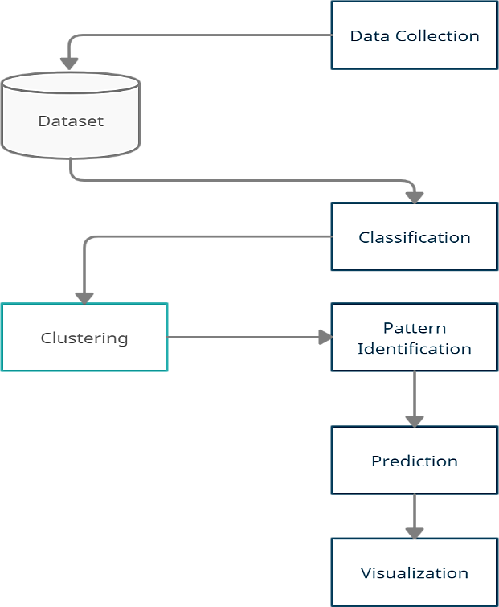

## 4.1.1 SYSTEM ARCHITECTURE

The system architectural design is the design process for identifying the subsystems making up the system and framework for subsystem control and communication. The goal of the architectural design is to establish the overall structure of software system which is shown figure.

Figure: System Architecture of SAR-Crime Analyzer 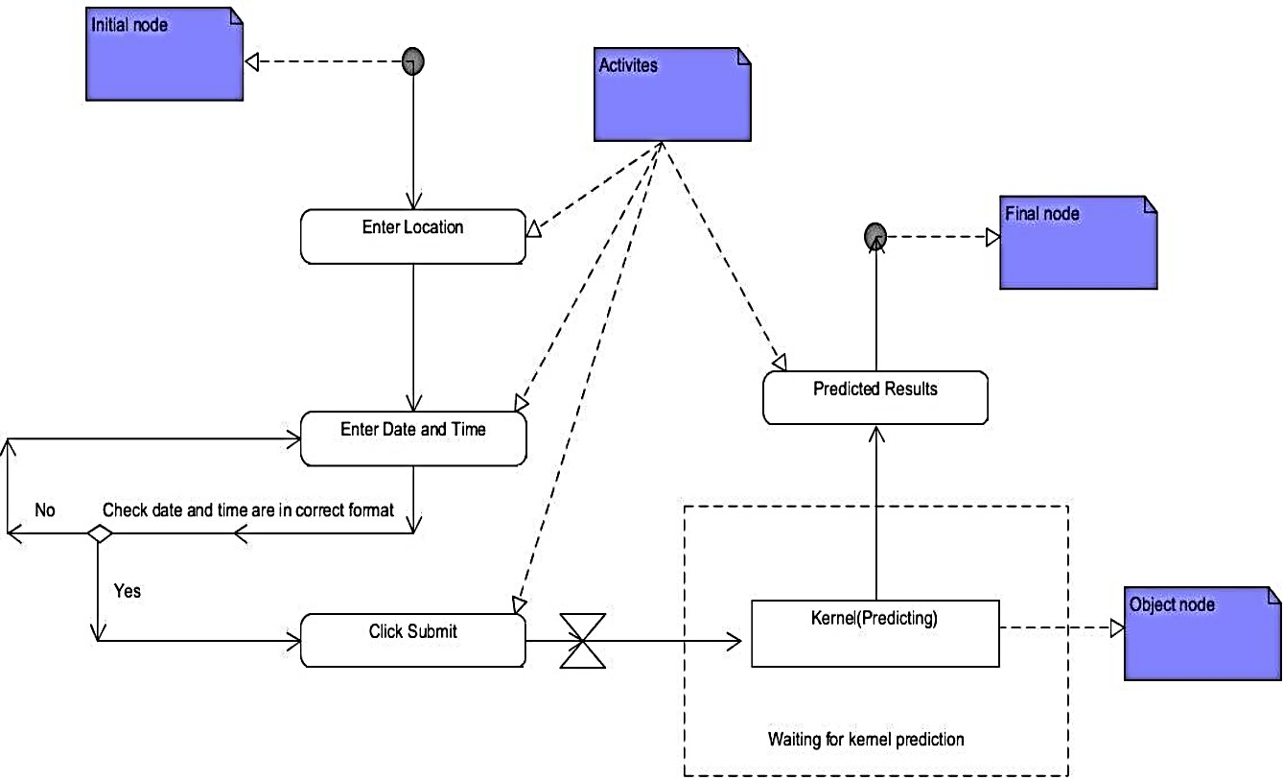

# Chapter 5: IMPLEMENTATION

The implementation of the project is done with the help of python language. To be particular, for the purpose of machine learning Anaconda is being used. Anaconda is one of several Python distributions. Anaconda is a new distribution of the Python. It was formerly known as Continuum Analytics. Anaconda has more than 100 new packages. Anaconda is used for scientific computing, data science, statistical analysis, and machine learning. On Python technology, we found out Anaconda to be easier.

Since it helps with the following problems:

* + - * Installing Python on multiple platforms.
      * Separating out different environments.
      * Dealing with not having correct privileges.
      * Getting up and running with specific packages and libraries.

This data was scraped from the publicly available data from Indore police website which had been made by people in police station of different areas. Implementation of the idea started from the Indore city itself so as to limit an area for the prediction and making it less complex. The data was sorted and converted into a new format of timestamp, longitude, latitude, which was the input that machine would be taking so as to predict the crime rate in particular location or city.

## 5.1 ENVIRONMENTAL SETUP

Environmental criminology is the study of crime as it occurs within a geographical area, and it's a positivist theory that suggests crime is influenced, if not caused, by a person's spatial environment. The basis is specifically how individuals, with all their diverse attributes, become influenced to commit crimes by the elements in their immediate location. For example, Theodore lives in an upper middle class neighborhood with its share of young families and corporate ladder climbers. On three sides are a park, a high-end shopping center, and a similar neighborhood. On its southern border is an economically disadvantaged area of town.

Theodore drives by a convenience store in that southern zone and buys cocaine. Using the classical method, a police sting operation arrests Theodore and some local sellers. Within days, the seller is replaced and more buyers return, unaware of Theodore's arrest. However, environmental criminologists, after studies of Theodore's crime zone, build police substations, enlist local churches and community centers to help clean up the area, and offer addiction classes. Government funds help build new sidewalks and street lights.

## **5.2** MODULE DESCRIPTION

## The crime analysis can be performed procedure which is similar to figure which specifies each module which is used for data mining and machine learning algorithm to predict the crime or form group of clusters of criminals according to crime records. The criminals can hold certain properties and their crime characteristics and crime careers may vary from one criminal to another. Such a type of information can be taken as the input dataset. The input dataset is given to a pre-processor which performs the pre-processing based on the requirements. Our system can predict regions which have high probability for crime occurrence and can visualize crime prone areas. With the increasing advent of computerized systems, crime data analysts can help the Law enforcement officers to speed up the process of solving crimes. It will also help to create a somewhat safer, crime-free neighbourhood for the citizens as they will be more aware of different types of crimes occurring and the time in which it is more likely to happen.

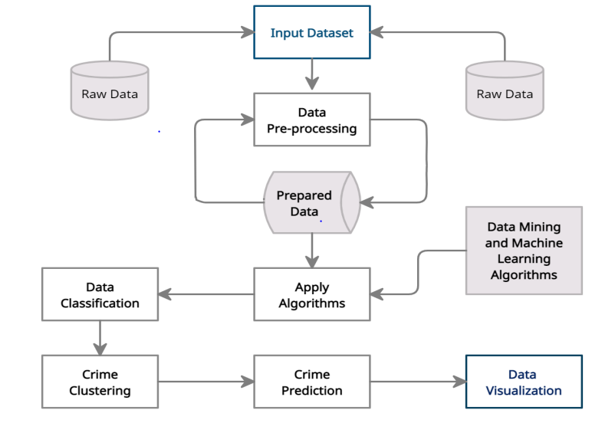

Figure : Crime Prediction and Crime clustering based on the input dataset

5.3 SOFTWARE DESCRIPTION

Crime analysis software can be as simple as a Microsoft Excel spreadsheet that targets crime reduction priorities for an agency or a more robust crime intelligence product which has the ability to integrate RMS and CAD data into powerful and customizable dashboards with analytics, query, visualization, and information sharing. Ideally, this software has the ability to provide visually-intuitive heat maps, trend analysis, charts, and is able to quickly uncover emerging trends gaining deeper insight into key issues and areas.

Crime analysis software tools should have the ability to use historical RMS data to produce targeted crime forecasts that are accurate. In any agency, utilizing crime analysis software in either a simple or more robust application should lead to more efficiently allocated Officer resources and help to improve the focus of their time and efforts on proactively reducing and preventing crime.

**5.4** SAMPLE CODES

**5.3.1 Frontend Codes**

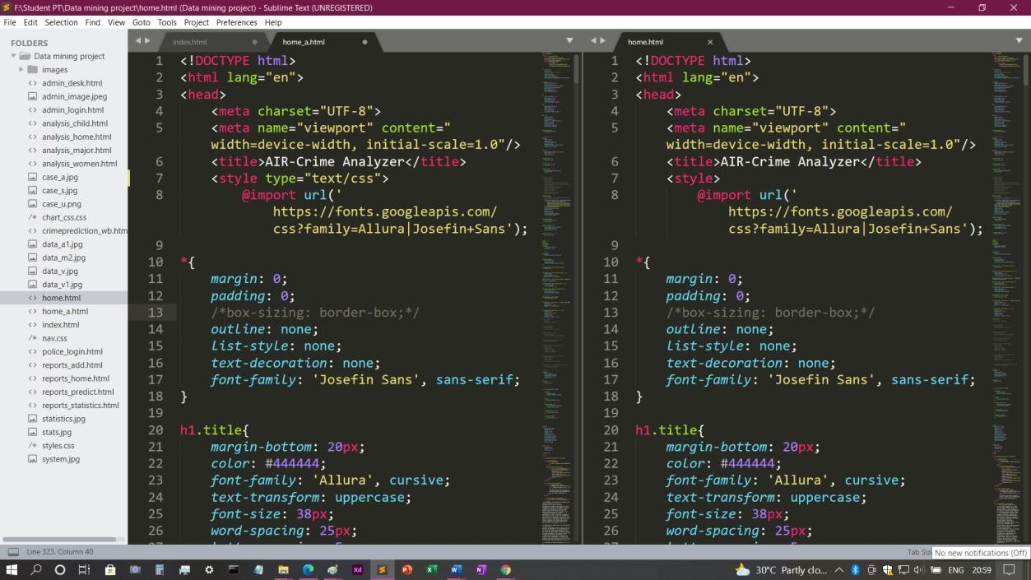

Figure :Sample Come for Home pages

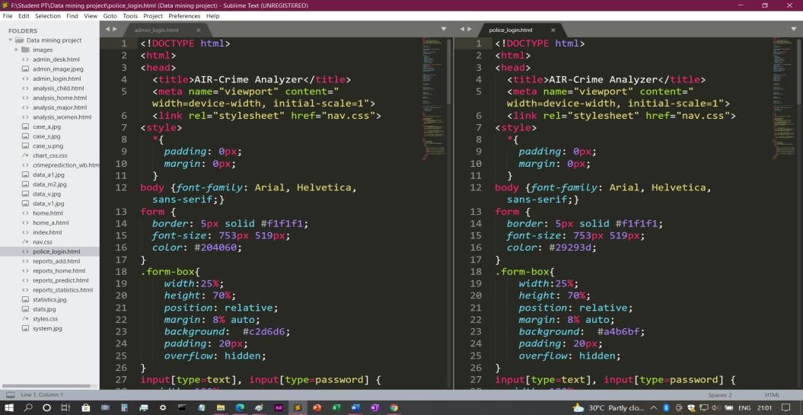

Figure: Sample Code for Login pages

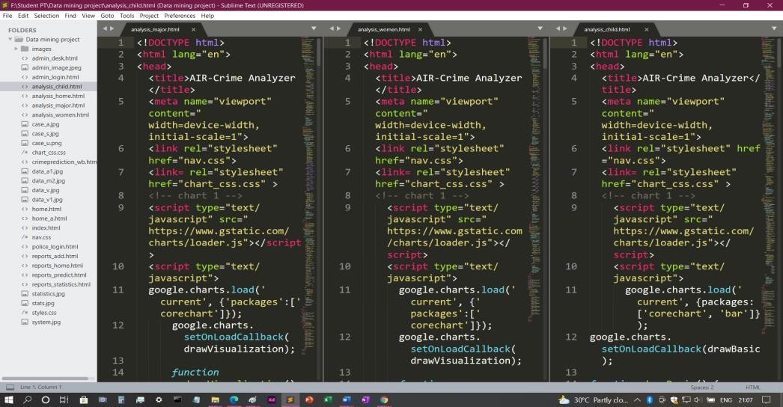

Figure: Sample Code for Crime Analysis

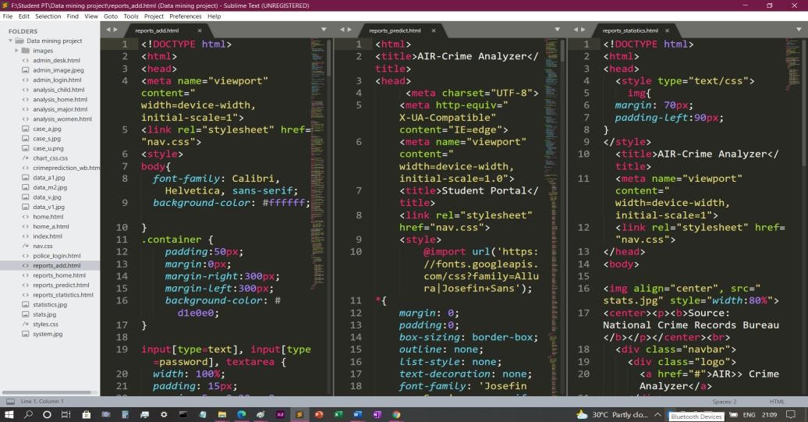

Figure : Sample Code for Crime Prediction

**5.3.2 Backend Codes**

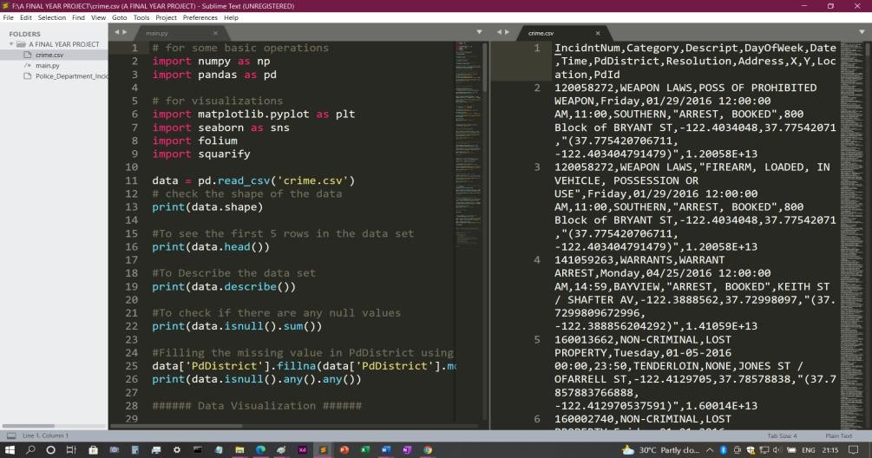

Figure: Sample Code for Crime Analysis using Python

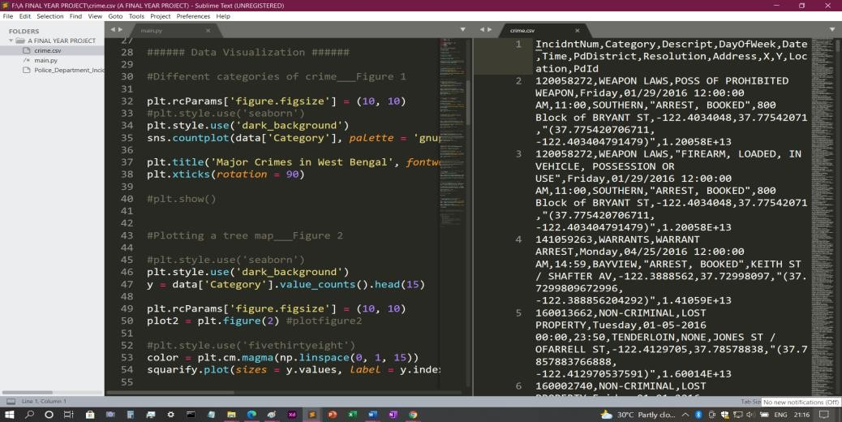

Figure : Sample Code for data visualization

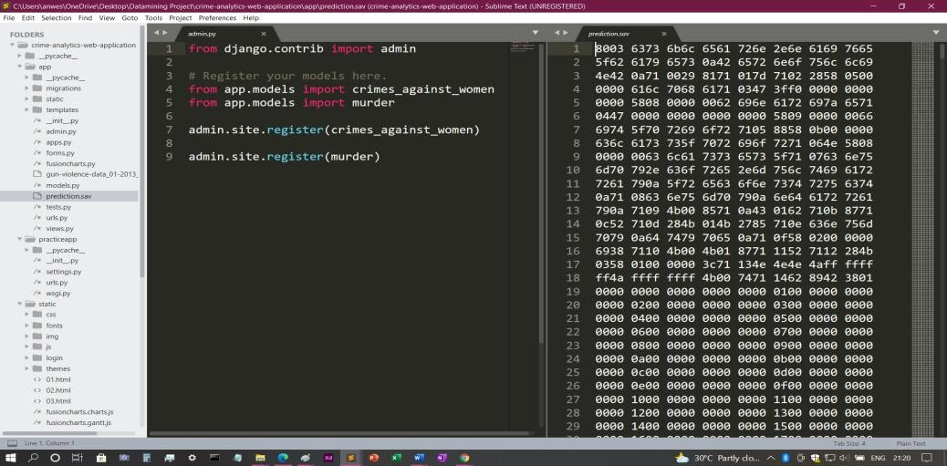

Figure : Extracting Data from date sets using Django.

**Chapter 5: SOFTWARE TESTING**

5.1 TYPES OF TESTING

The system provides secured and accurate record of data about reported crimes in India. The main pillar of reliability of the system is the backup of the database, which is continuously maintained and updated to reflect the most recent changes. The overall stability of the system depends on the stability of the application and the databases.

The system should be available at all times, mean the user can access it using their registered accounts anytime and anywhere. In case of a hardware failure or database corruption, a replacement interface will be shown. Also, in case of a hardware failure or database corruption, backups of the database should be retrieved from the server and saved by the administrator. Then the service will be restarted. It means 24 X 7 availability.

The system is very easy to maintain and all cached data will be rebuilt during every start-up. There is no recovery of user data if it is lost, Default values of system data will be assigned when necessary

**Chapter 7: RESULT SCREENSHOTS**

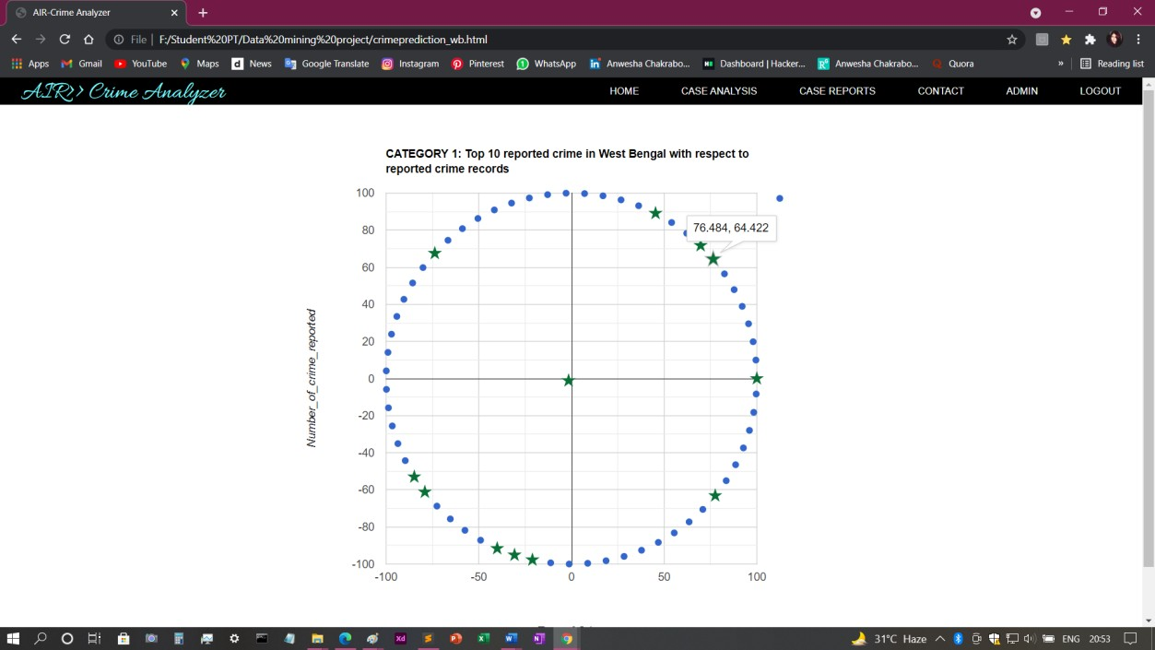

**Chapter 8: CONCLUSION**

An acceptable model for data mining which comes up with excellent results of analysing crime data set; it requires huge historical data that can be used for creating and testing the model. More than 150500 crime records that were used in this work can give estimation and lead to an acceptable model. VS Code and Excel software were used to pre-process and analyse the collected crime and criminal data. In this paper we have tested the accuracy of classification and prediction based on different test sets. Classification is done based on the Bayes theorem which showed more than 90% accuracy. Using this algorithm, we trained numerous news articles and build a model dataset. For testing we are inputting some test data into the model which shows better results. Our system takes factors/attributes of a place and Apriori algorithm gives the frequent patterns of that place. The pattern is used for building a model for decision tree. Till now we trained our system using certain attributes but we are planning to include more factors to improve accuracy.

**8.1** BIBLOGRAPHY

1. Malathi. A and Dr. S. Santhosh Baboo. Article:an enhanced algorithm to predict a future crime using data mining. International Journal of Computer Applications, 21(1):1–6, May 2011. Published by Foundation of Computer Science.
2. Eibe Frank and Remco R. Bouckaert. Naive bayes for text classification with unbalanced classes. In Proceedings of the 10th European Conference on Principle and Practice of Knowledge Discovery in Databases, PKDD’06, pages 503–510, Berlin, Heidelberg, 2006. Springer-Verlag.
3. Ralf Hartmut Güting. Graphdb: Modeling and querying graphs in databases. In Proceedings of the 20th International Conference on Very Large Data Bases, VLDB ’94, pages 297–308, San Francisco, CA, USA, 1994. Morgan Kaufmann Publishers Inc
4. Lior Rokach and Oded Maimon. Decision trees. In Oded Maimon and Lior Rokach, editors, The Data Mining and Knowledge Discovery Handbook, pages 165–192. Springer, 2005.
5. Tong Wang, Cynthia Rudin, Daniel Wagner, and Rich Sevieri. Detecting patterns of crime with series finder. In Proceedings of the European Conference on Machine Learning and Principles and Practice of Knowledge Discovery in Databases (ECMLPKDD 2013), 2013.
6. R. Sanjana, H. S. S, and S. Sruthi, ‘Big Data Approach for Crime Classification and Visualization Using Crime Dataset’, Int. J. Innov. Res. Sci. Eng. Technol., vol. 7, no. 2, pp. 25–29, 2018.
7. A. Jain and V. Bhatnagar, ‘Crime Data Analysis Using Pig with Hadoop’, Procedia Comput. Sci., vol. 78, no. December 2015, pp. 571–578, 2016.
8. N. G. Karthigaa and M. K. B. Janani, ‘Big Data Prediction on Crime Detection’, in National Conference on Computational Intelligence Systems, 2017, pp. 43–48.
9. V. N. Inukollu, S. Arsi, and S. Rao Ravuri, ‘Securit y Issues Associated with Big Data in Cloud Computing’, Int. J. Netw. Secur. Its Appl., vol. 6, no. 3, pp. 45–56, 2014.
10. H. V. Jagadish et al., ‘Big data and its technical challenges’, Commun. ACM, vol. 57, no. 7, pp. 86–94, 2014.
11. D. C. Ukpabi, ‘Statistical Analysis on Crime Rate in Nigeria’, 2018.
12. O. Faweya, A. T. Adeniran, and K. O. Balogun, ‘Principal Component Analysis of Crime Rate in Nigeria : A Case Study of Ekiti and Osun State’, Am . J. Math. Stat., vol. 8, no. 4, pp. 79–88, 2018.
13. A. Hills, ‘Partnership policing: Is it relevant in Kano, Nigeria?’, Criminol. Crim. Justice, vol. 14, no. 1, pp. 8–24, Feb. 2014.
14. Nurhayati, Busman, and V. Amrizal, ‘Big Data Analysis Using Hadoop Framework and Machine Learning as Decision Support System (DSS) (Case Study: Knowledge of Islam Mindset)’, in 2018 6th International Conference on Cyber and IT Service Management, CITSM 2018, 2018, no. Citsm, pp. 1–6.
15. M. P.K, ‘Technology’s Ways: Information Technology, crime analysis and the rationalizing of policing’, SAGE, vol. 1, no. 1, pp. 83–103, 2015.
16. K. Overland Park, ‘Definition and Types of Crime Analysis (White Paper 2014-02)’, 2014.

LIST OF FIGURES

1.Use case diagram

Use case diagram represent the overall scenario of the system. A scenario is nothing but a sequence of steps describing an interaction between a user and a system. Thus, use case is a set of scenarios tied together by some goal. The use case diagram is drawn for exposing the functionalities of the system.

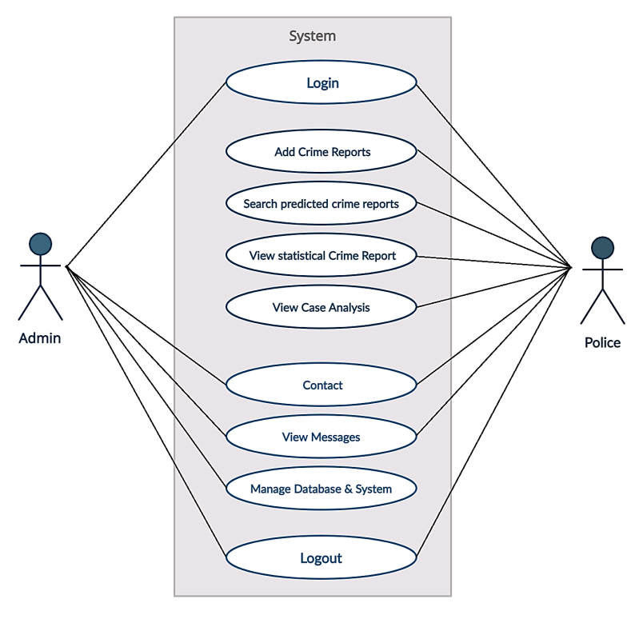

Figure 1: Use-case Diagram of SAR-Crime Analyzer

2.Activity diagram

The activity diagram is a graphical representation for representing the flow of interaction within specific scenarios. It is similar to a flowchart in which various activities that can be performed in the system are represented. Figure, represents the activity of the admin and Figure 11, represents the activity of police.

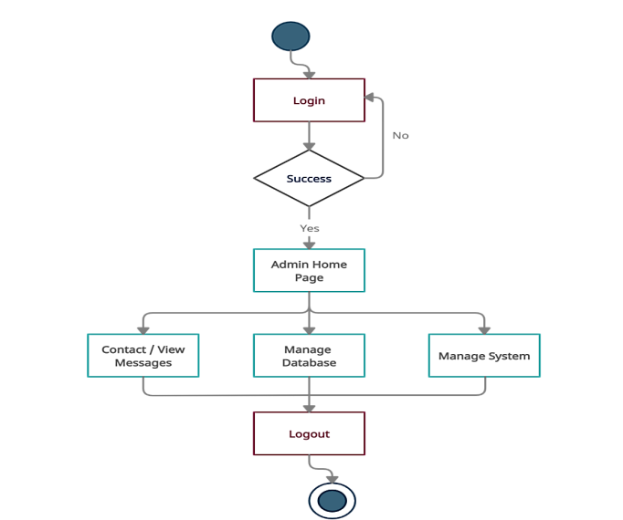

Figure: Admin Activity Diagram

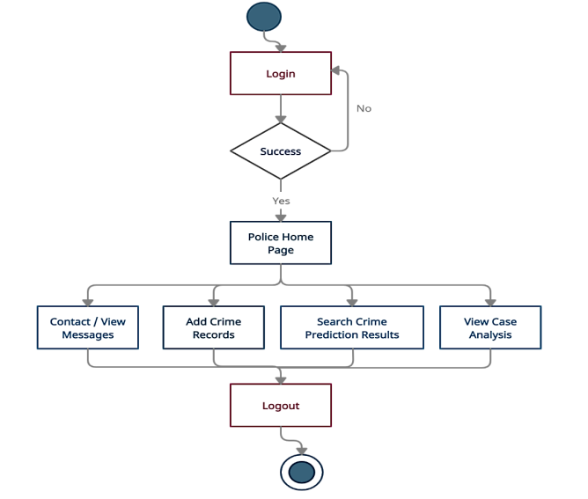

Figure : Police Activity Diagram

3.Sequence Diagram

In the sequence diagram how, the object interacts with the other object is shown. There is sequence of events that are represented by a sequence diagram. It is a time-oriented view of the interaction between objects to accomplish a behavioural goal of the system. Figure, represents the job sequence of police and Figure, represents the job sequence of the admin.

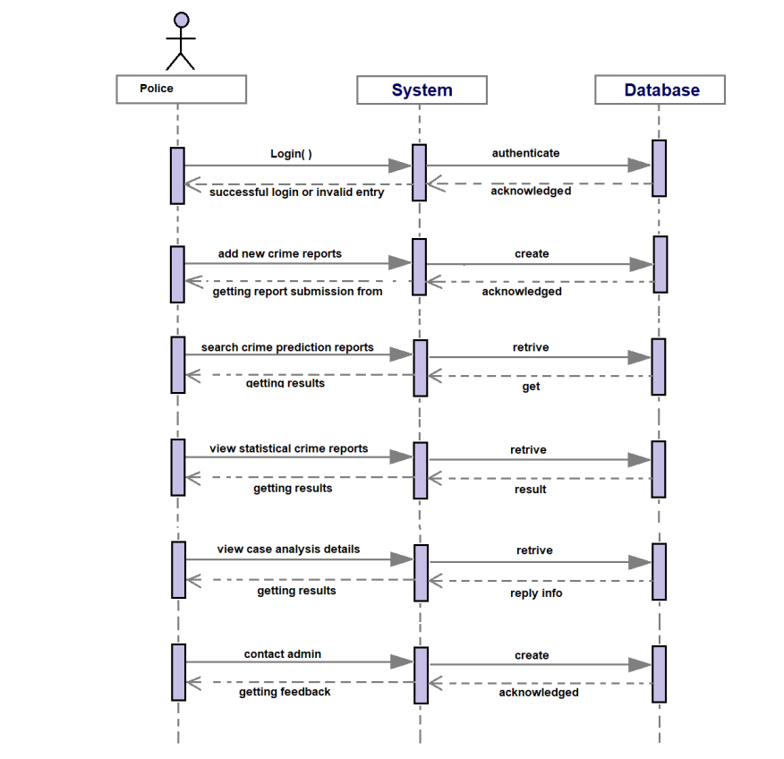

Figure: Sequence diagram for police user

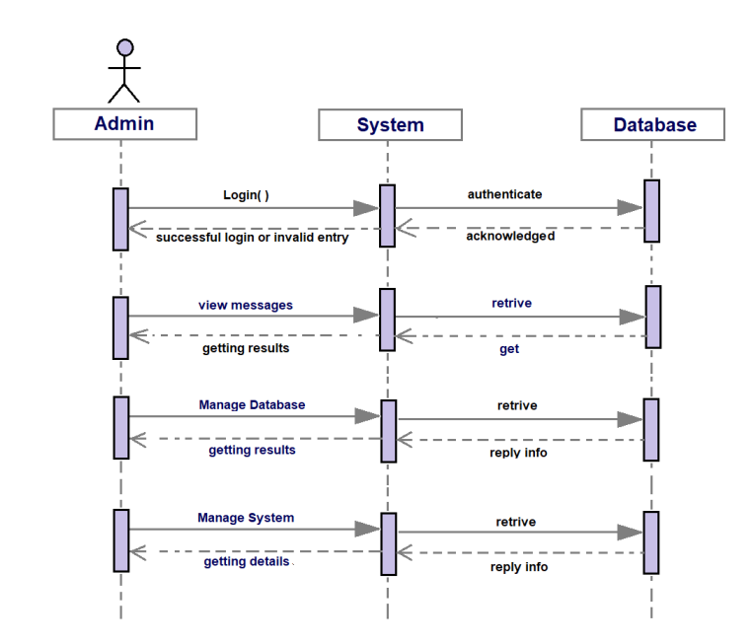

Figure: Sequence diagram for admin.

LIST OF SCREENSHOTS





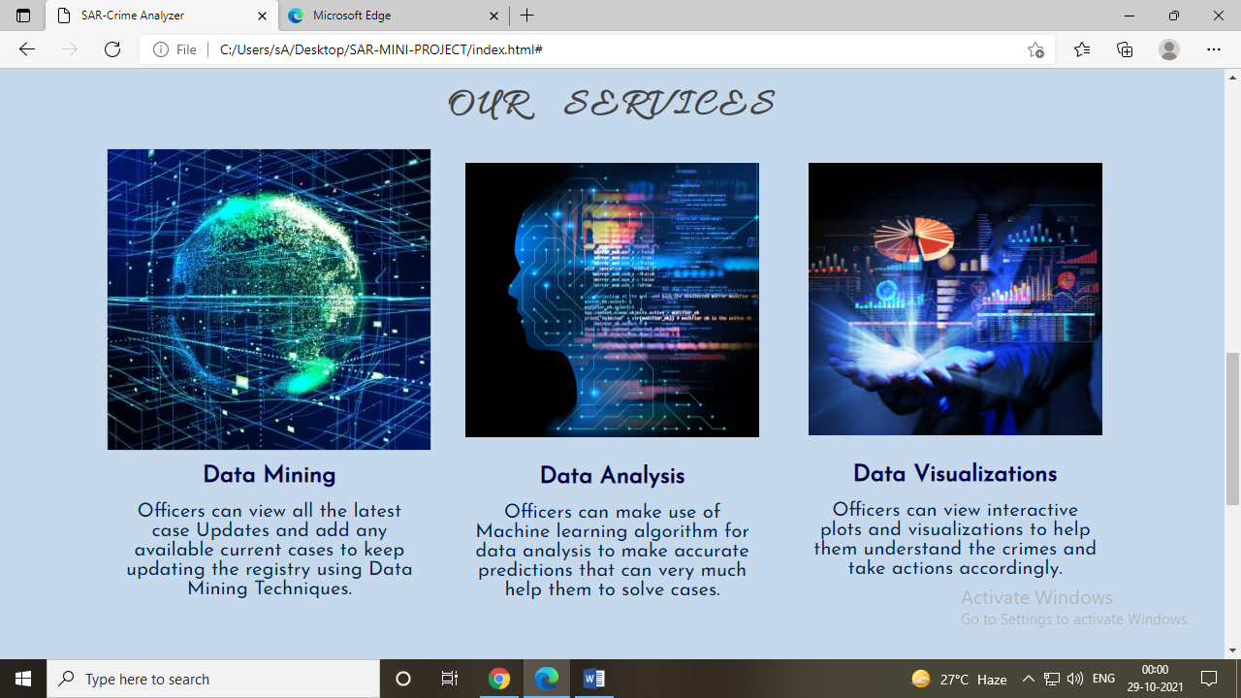

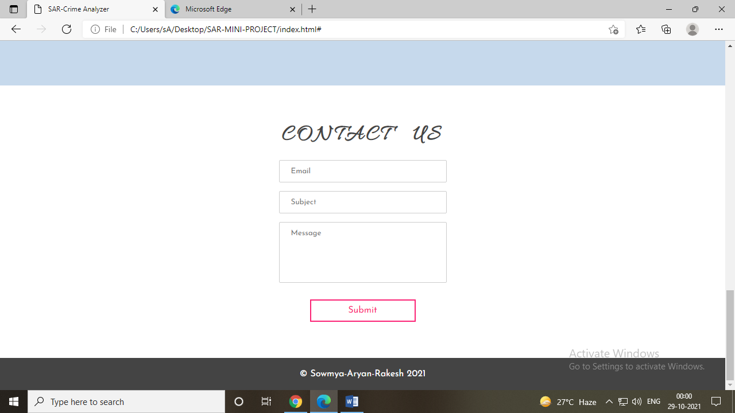

Figure 1: AIR-Crime Analyzer Home Page

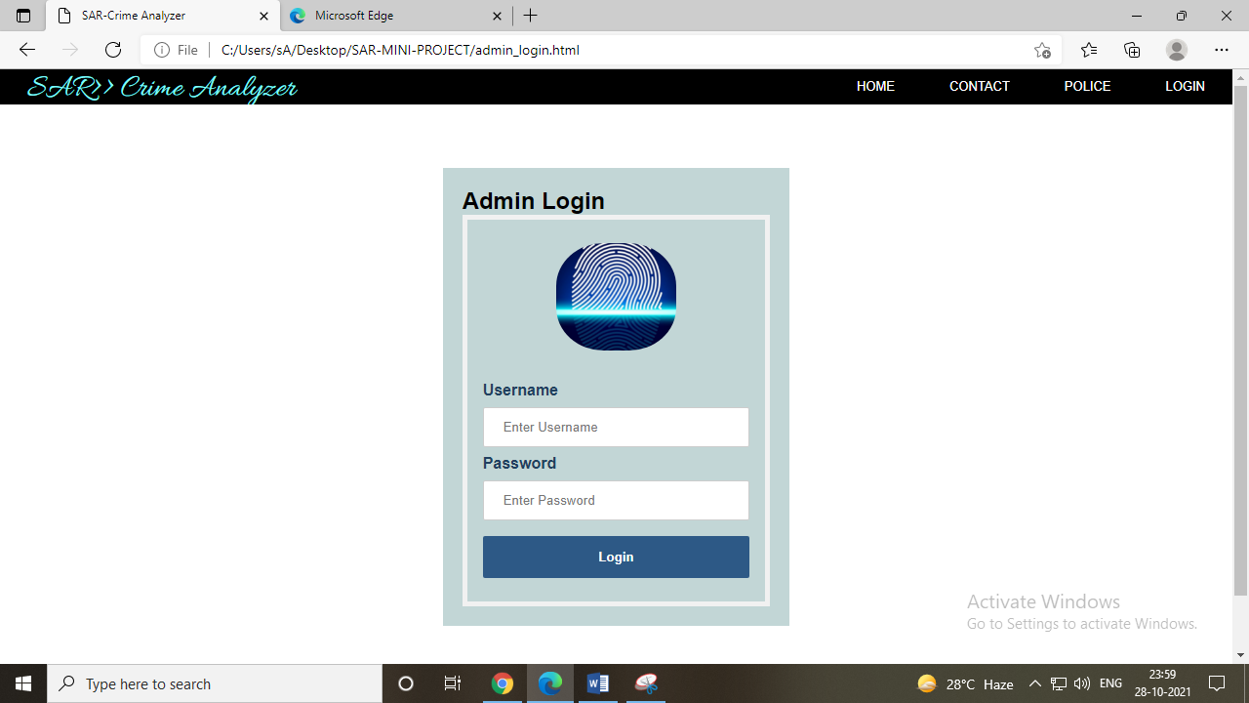

Figure 2: Admin Login Page



Figure 3: Admin Home Page

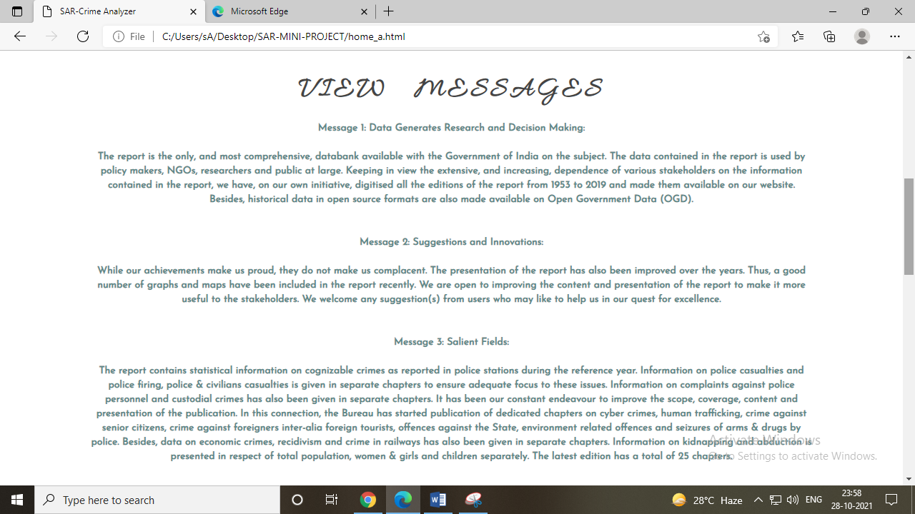

Figure 4: Admin-View Messages

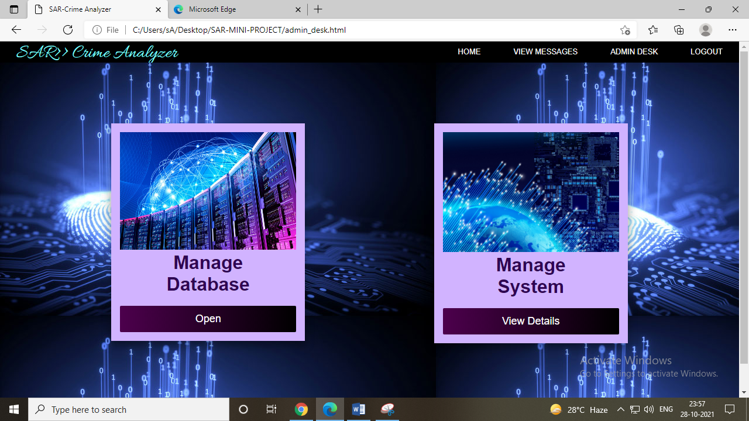

Figure 5: Admin Desk

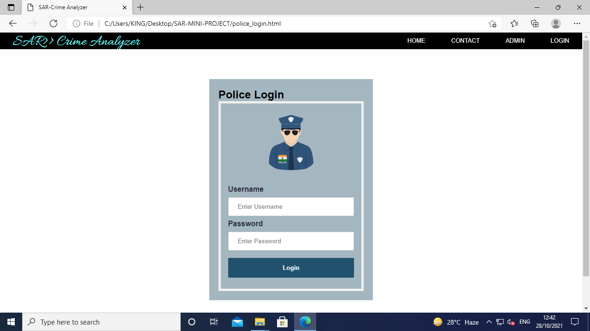

Figure 6: Police-Contact Admin



Figure 7: Police Home Page

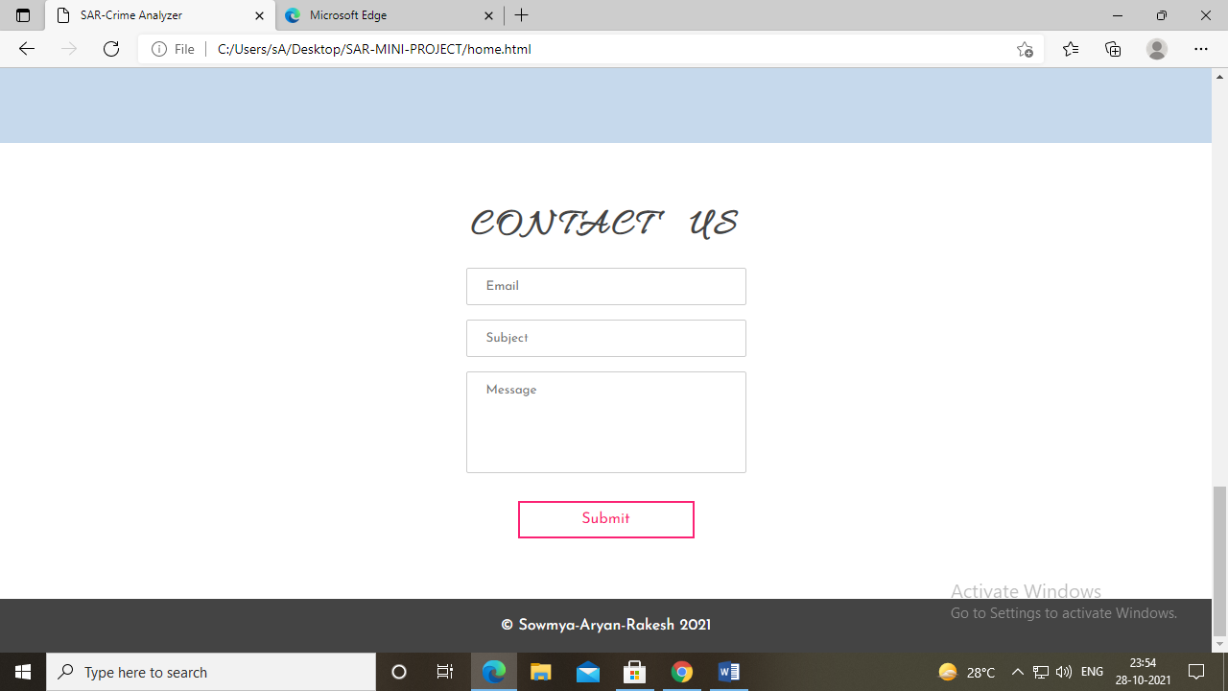

Figure 8: Police-Contact Admin

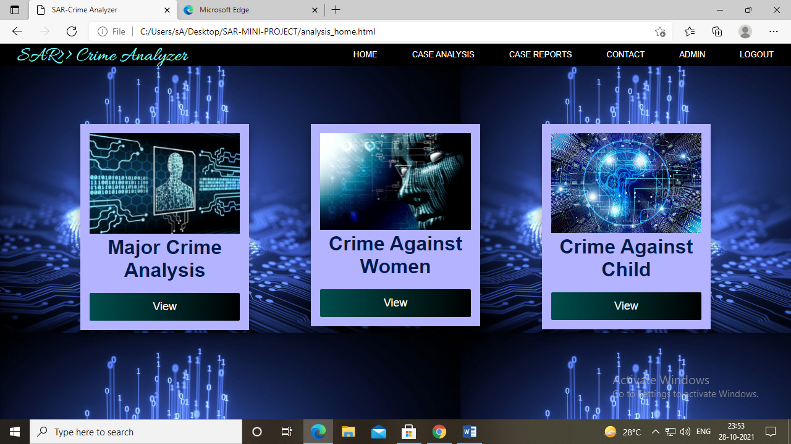



Figure 9: Case Analysis Home

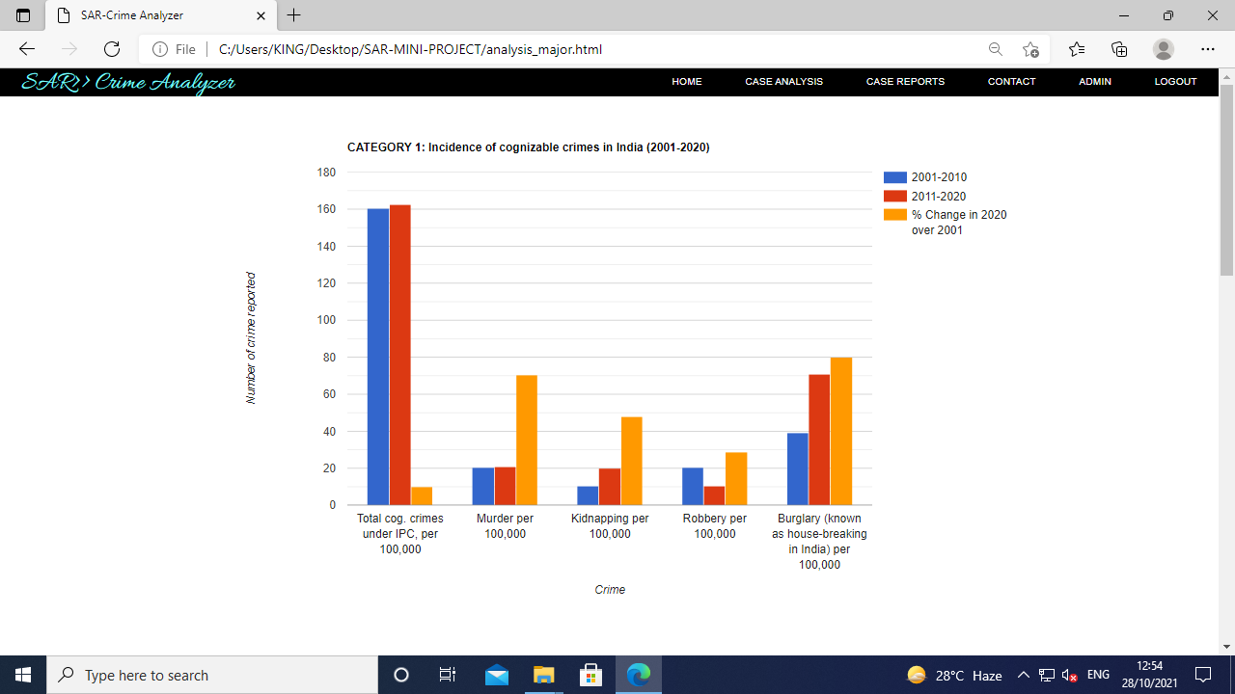

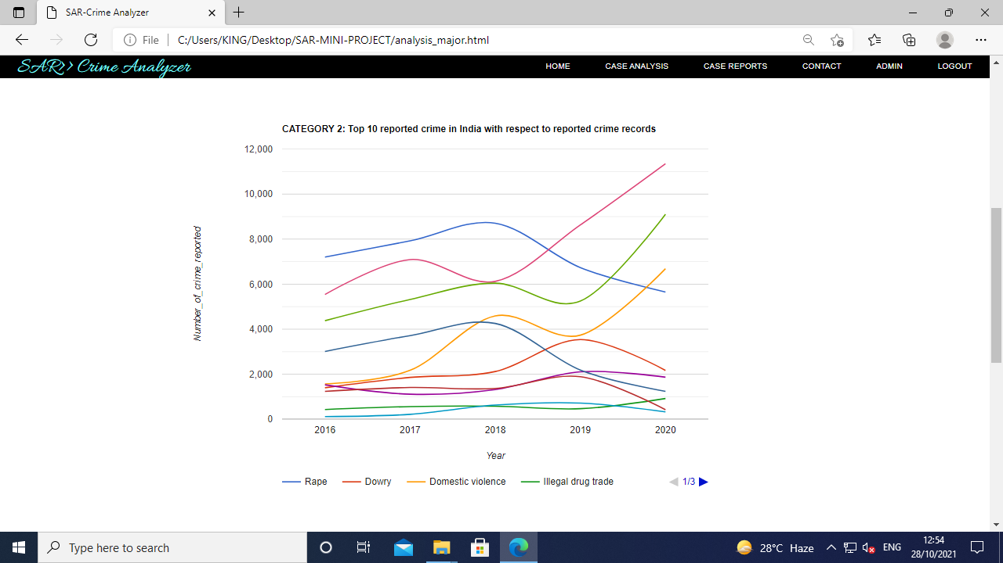

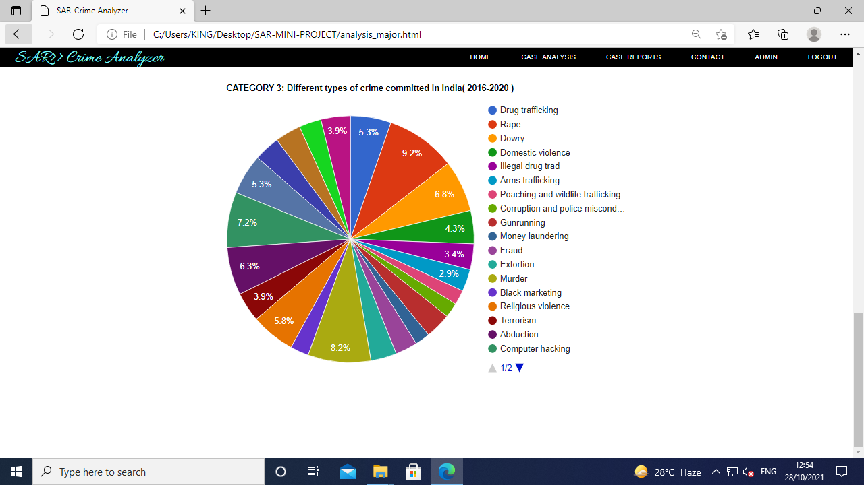

Figure 10: Major Crimes in India

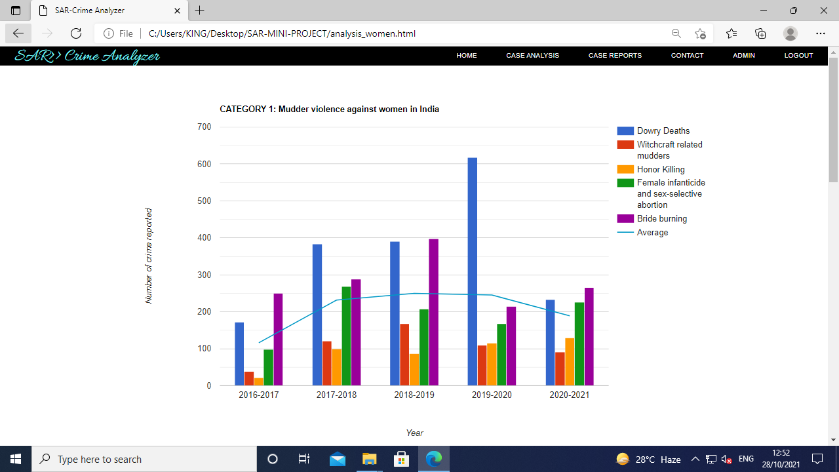

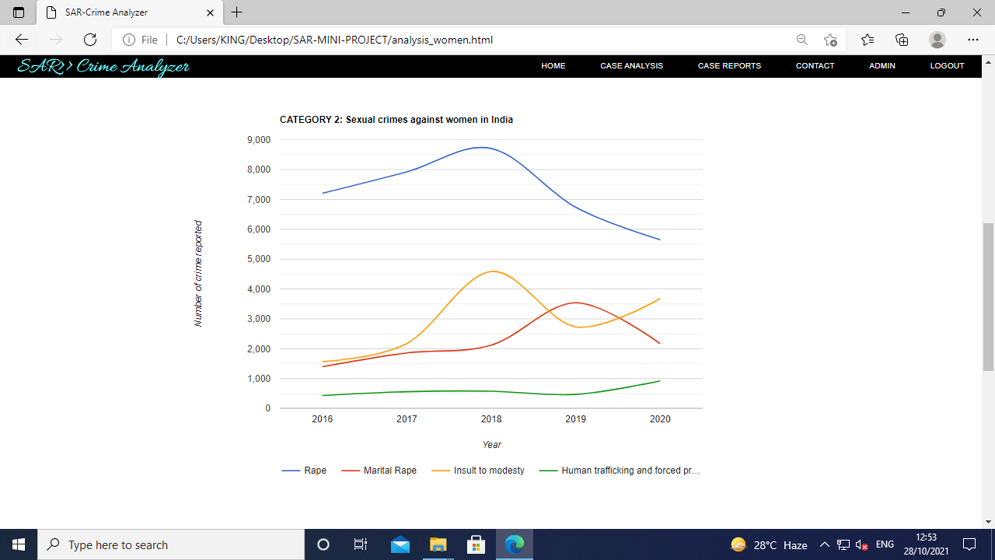

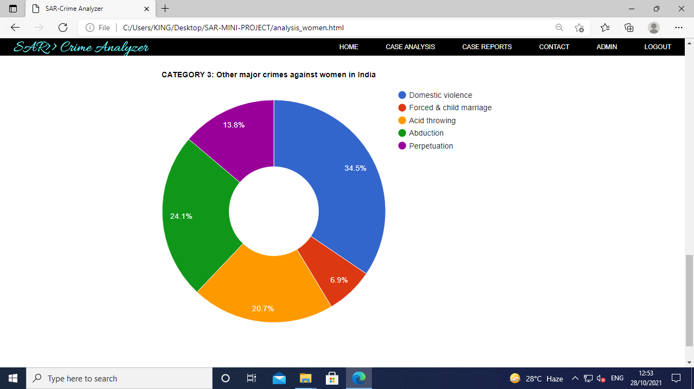

Figure 11: Crime against Women

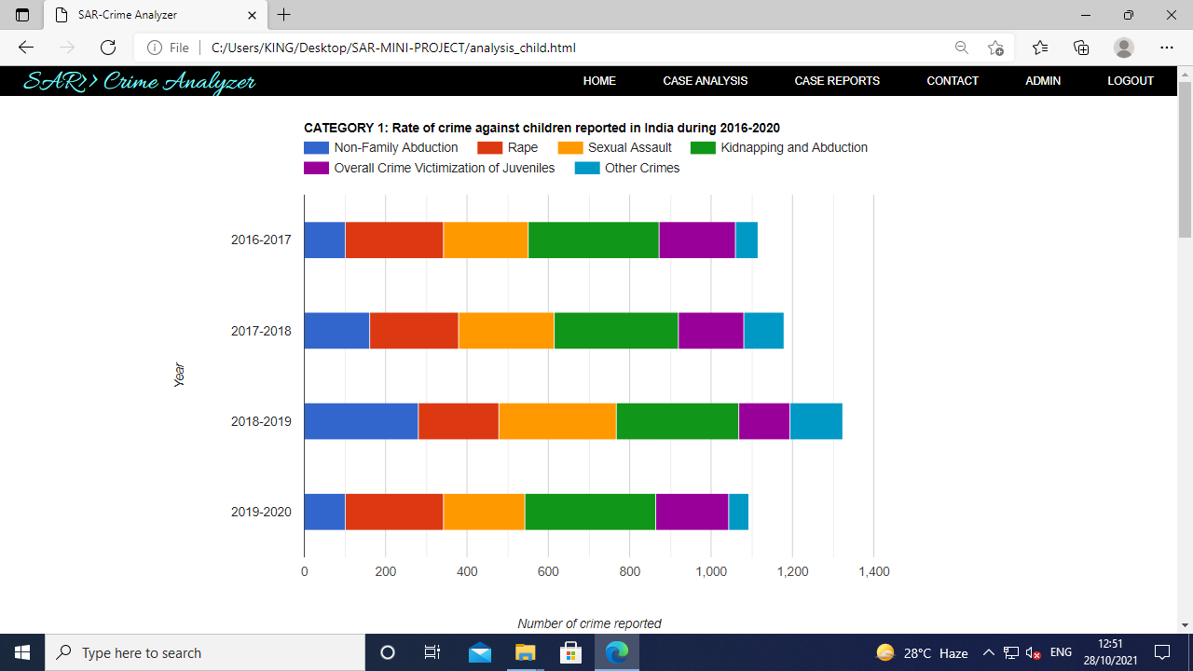

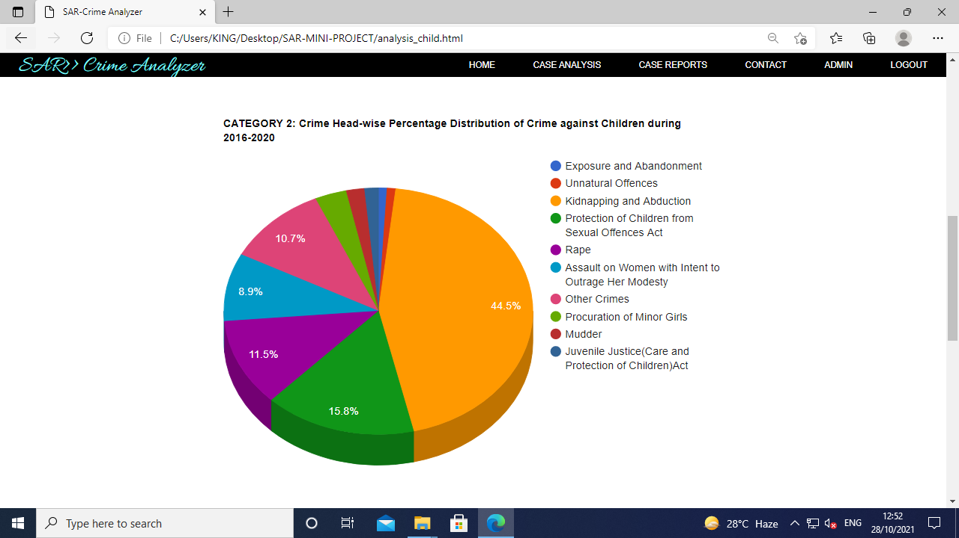

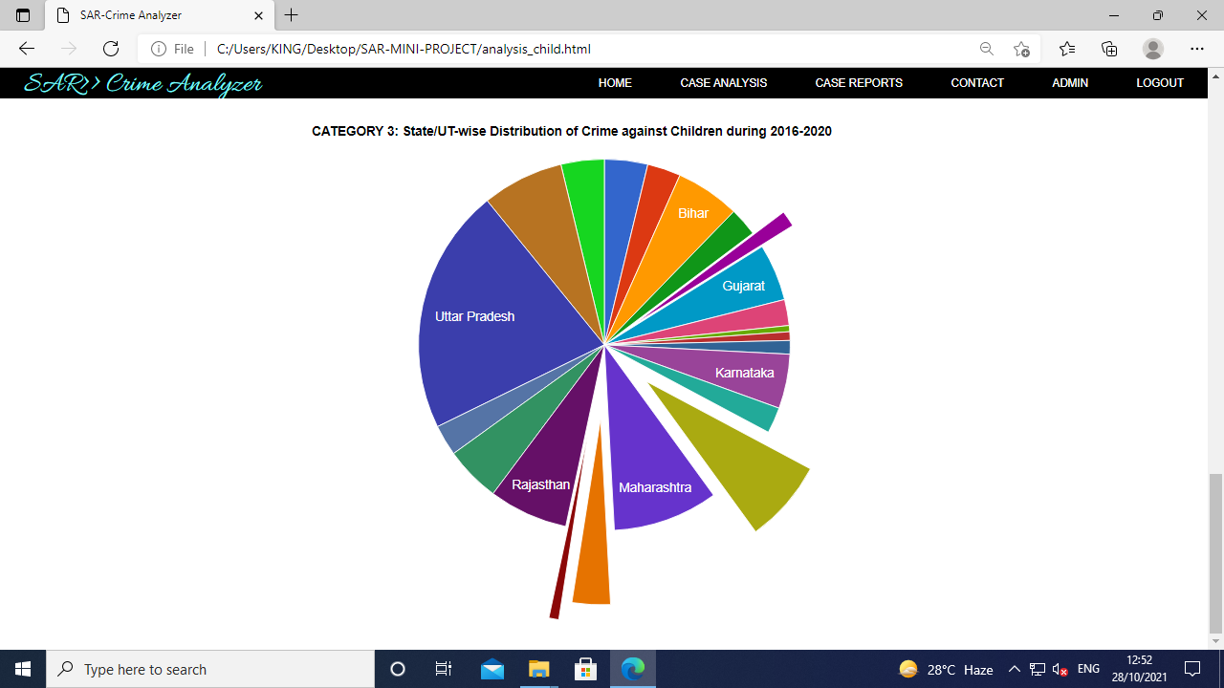

Figure 12: Crime against Child

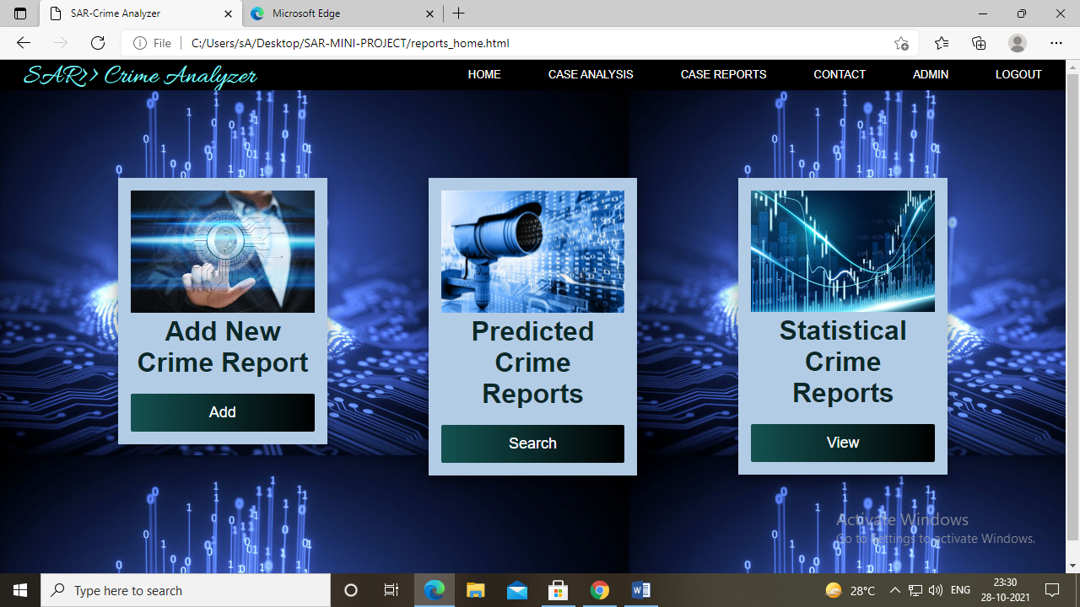

Figure 13: Crime Reports Home

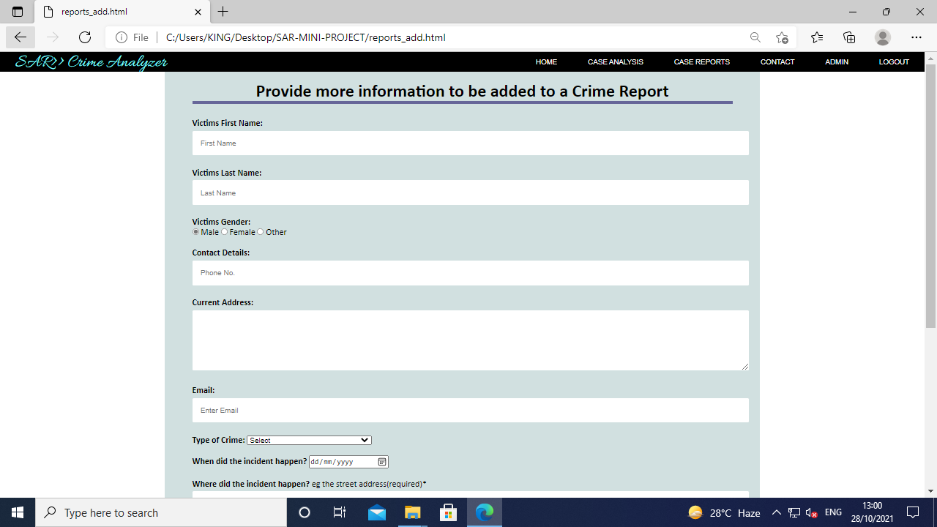

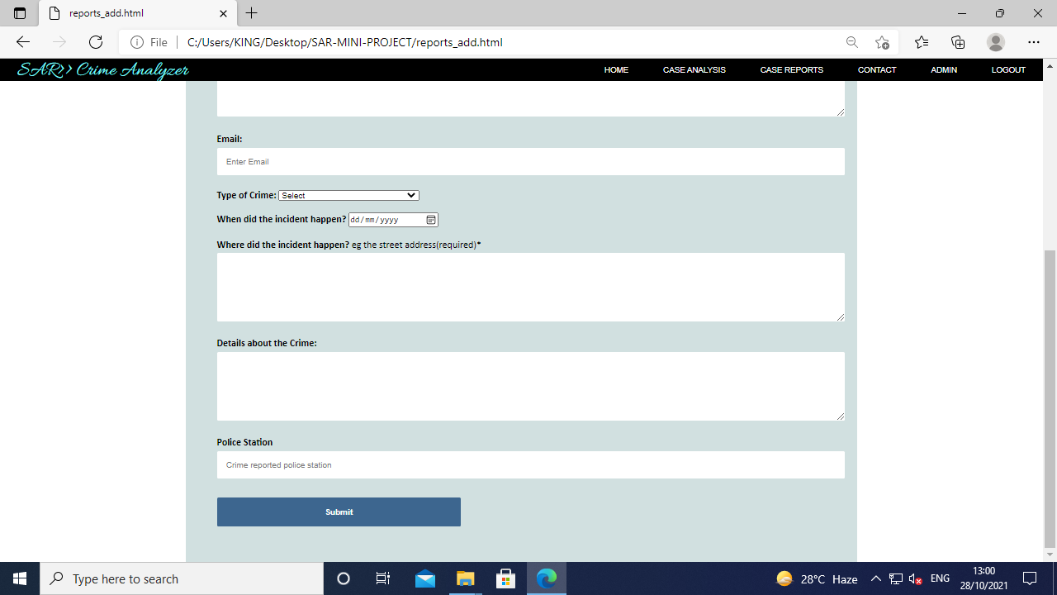

Figure 14: Crime report form

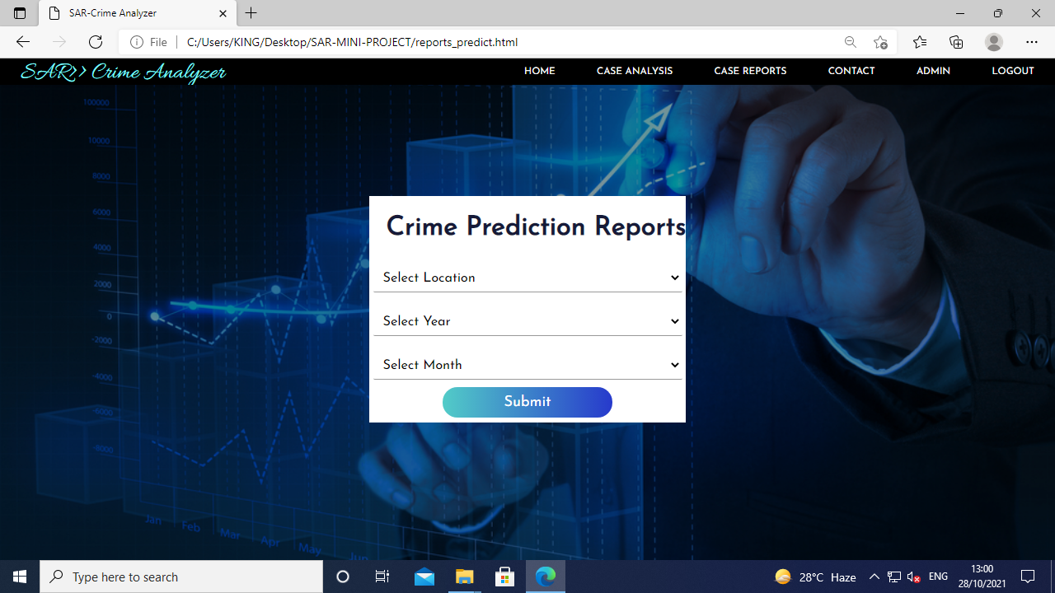

Figure 15: Crime Prediction Home

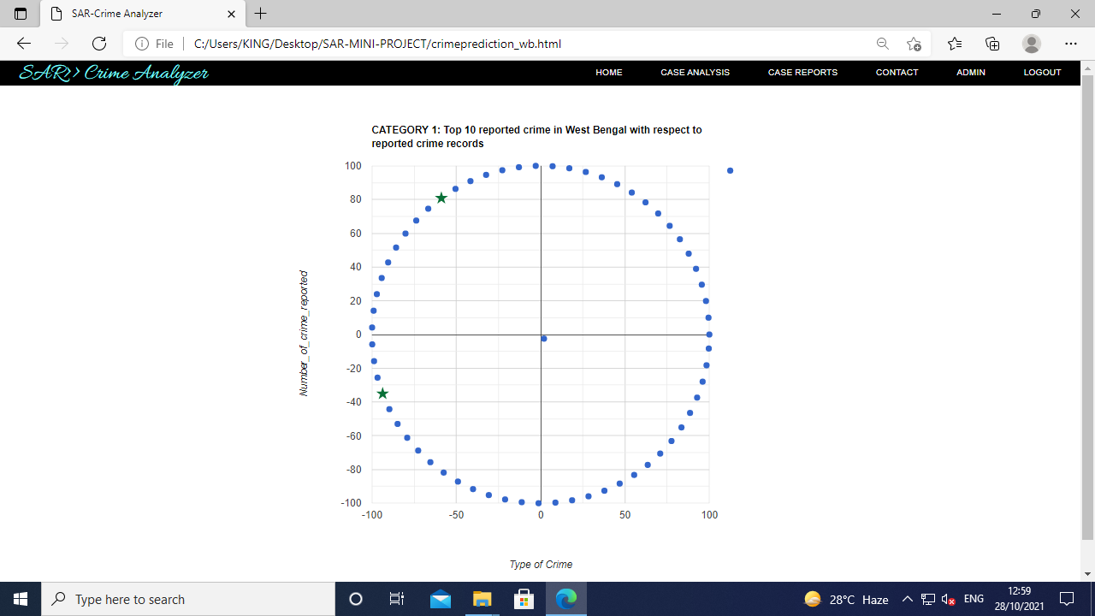

Figure 16: Crime prediction results

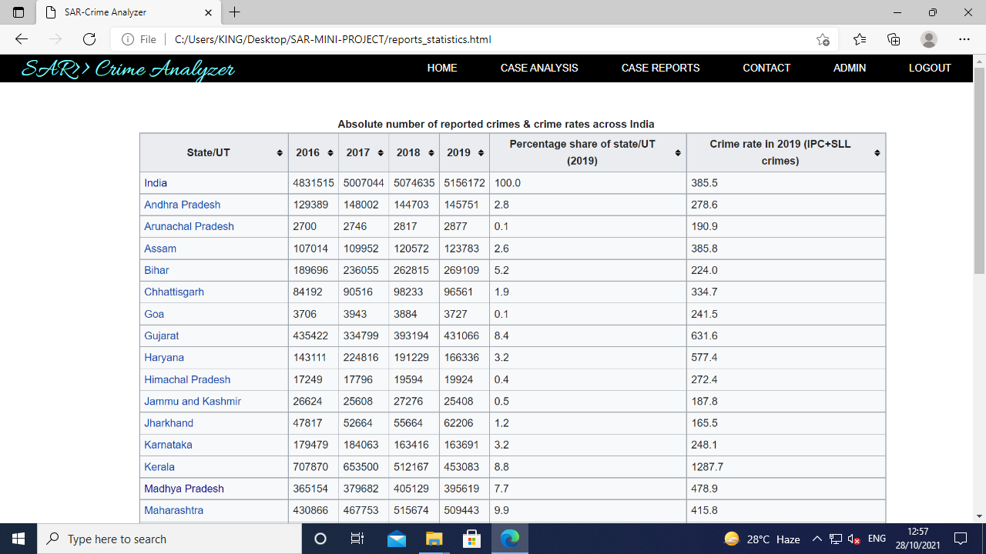

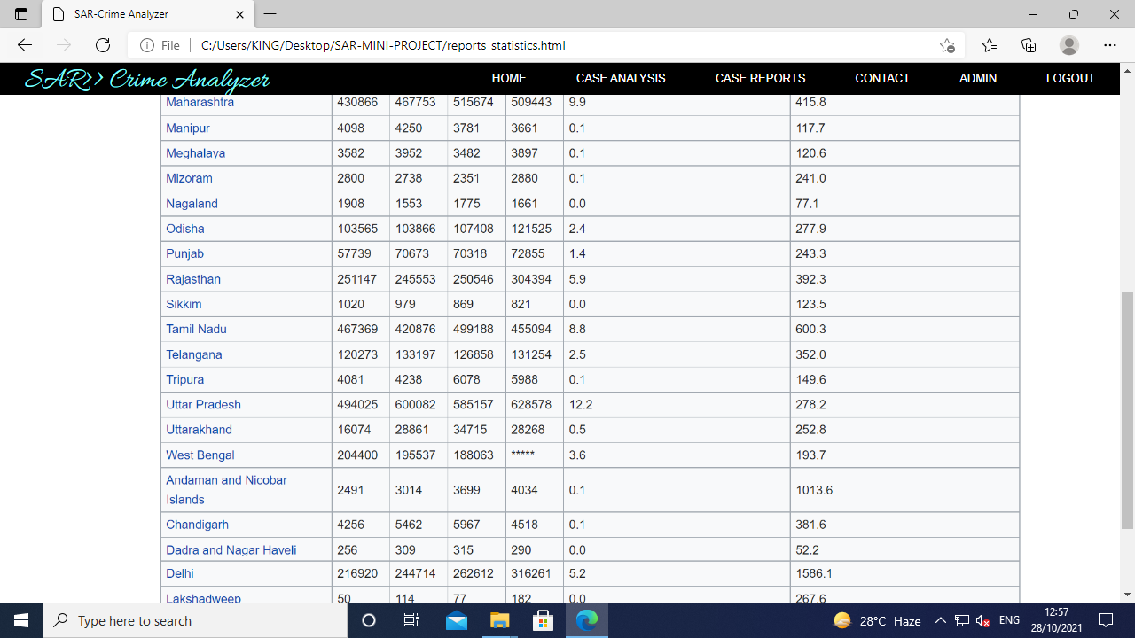

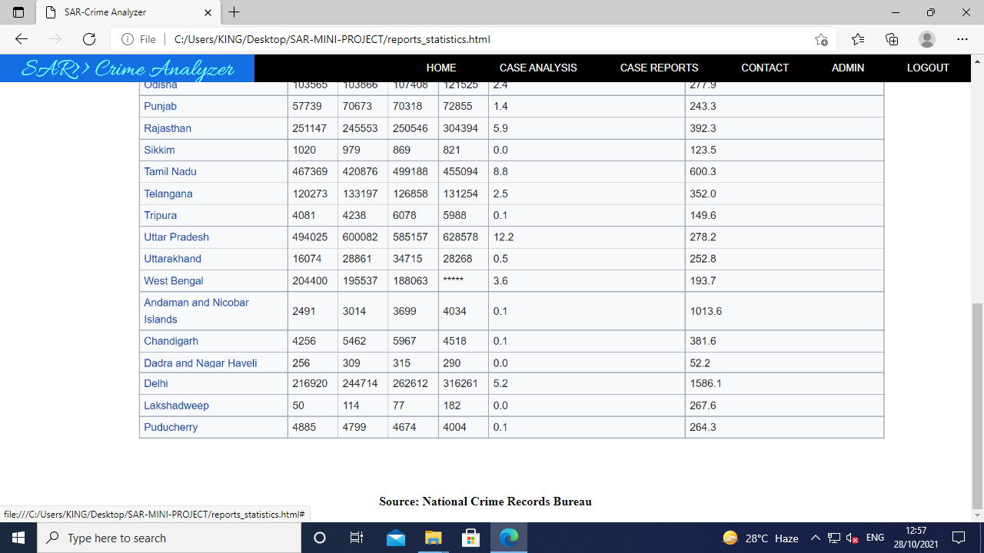

Figure 17: Statictics of crime reports in India